NAME : s . shruthika
REG NO :192110032
COURSE :COMPUTER ARCHITECTURE
CODE :CSA1288
FACULTY :DR.MARY VALANTINA.G
DATE :08/10/22

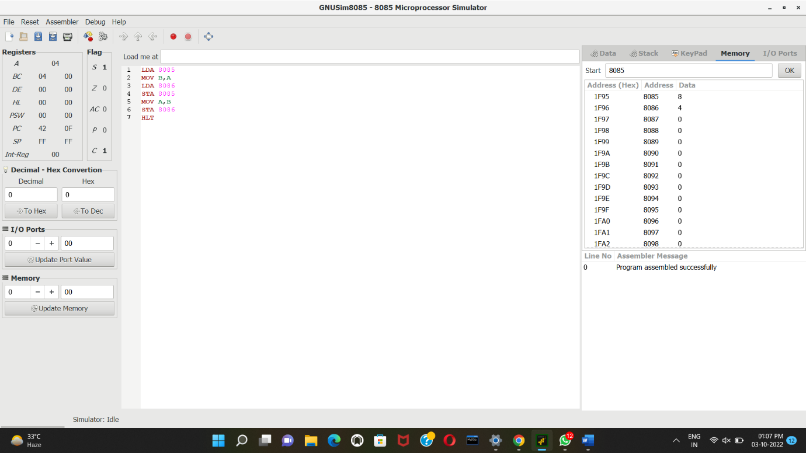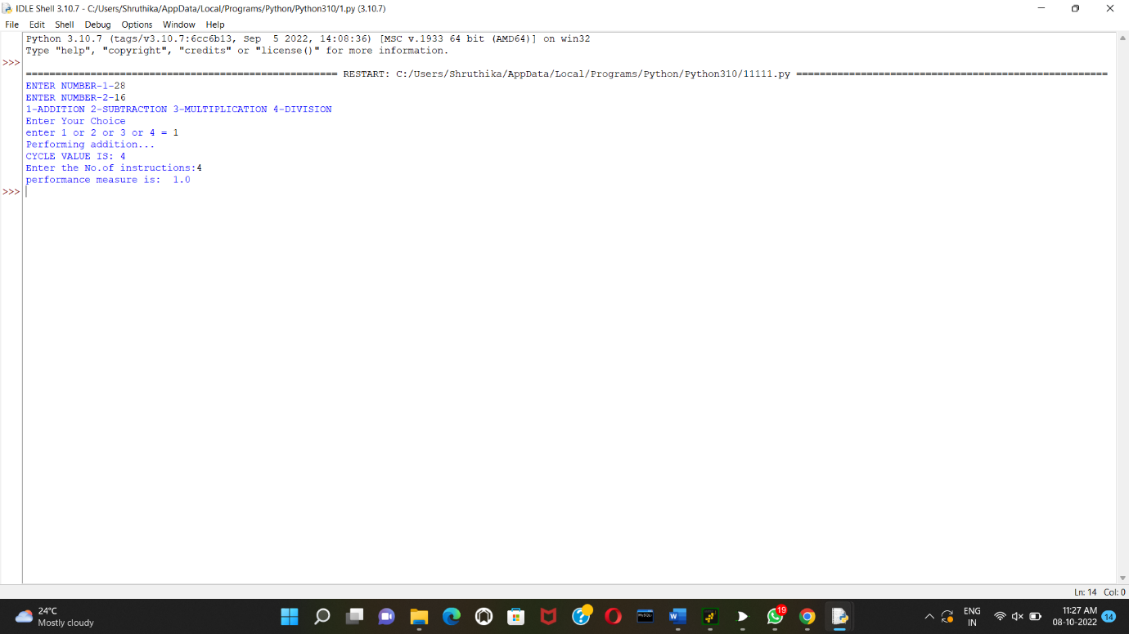
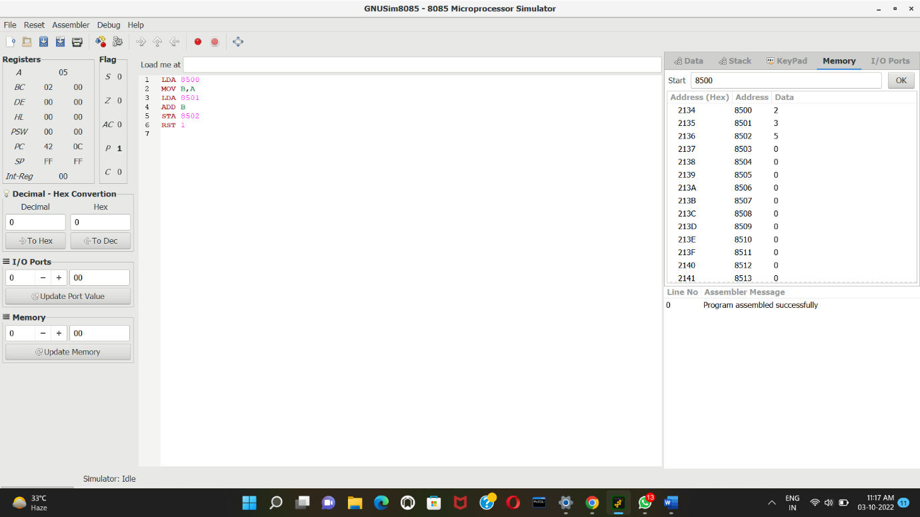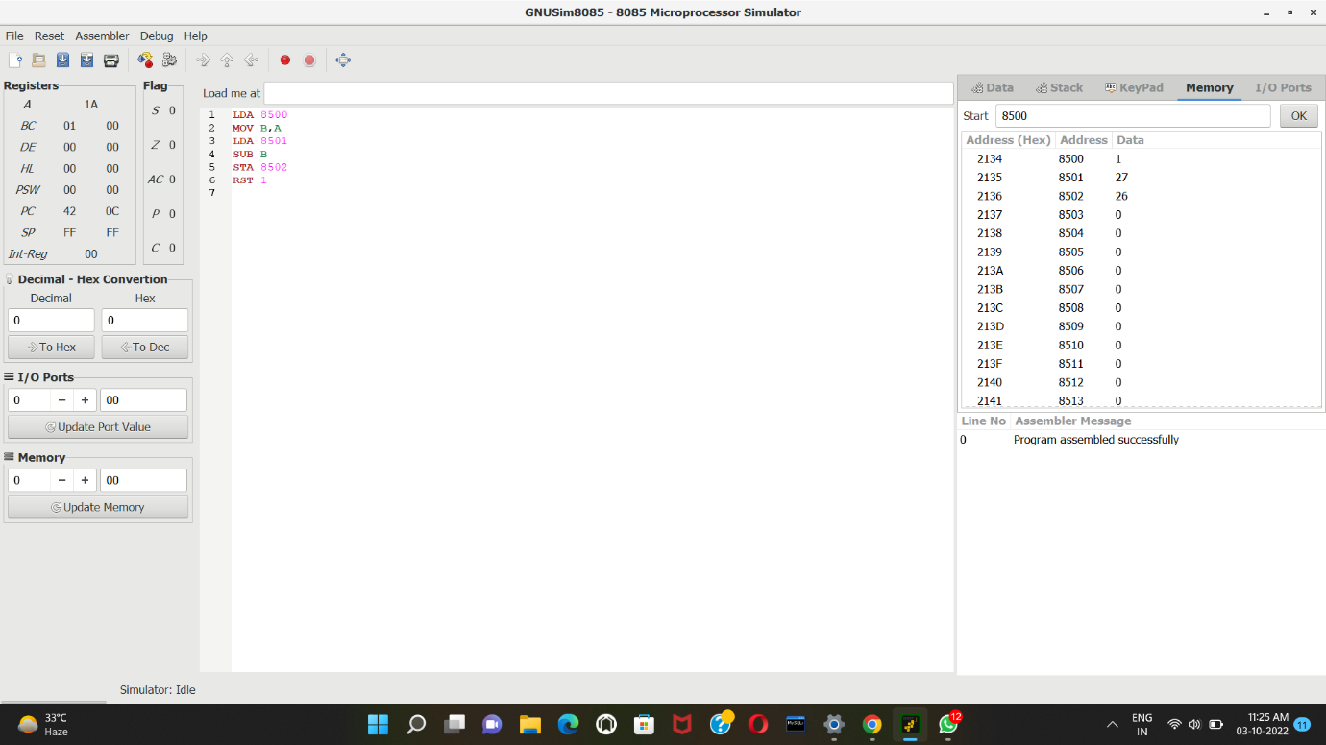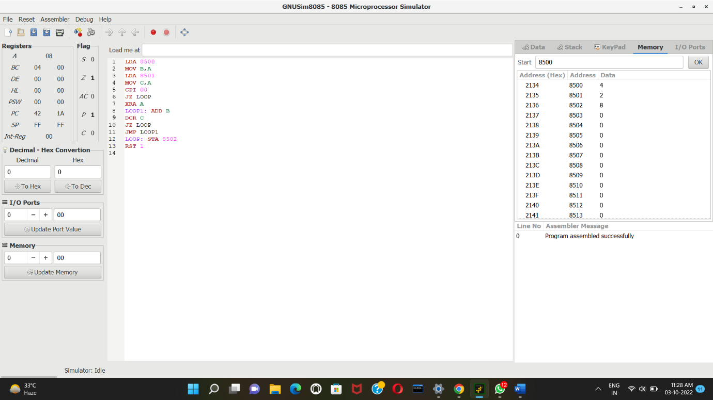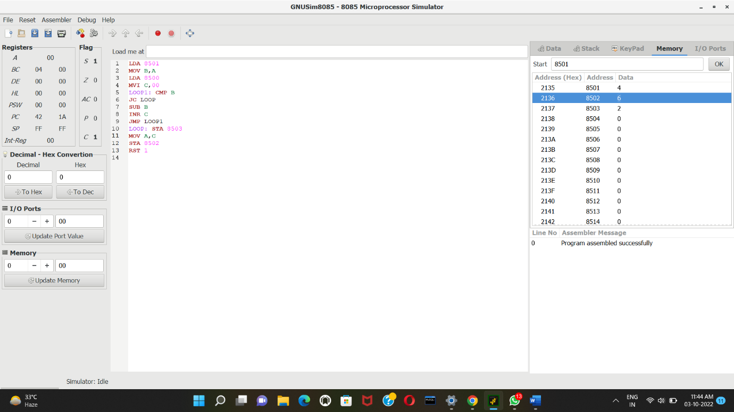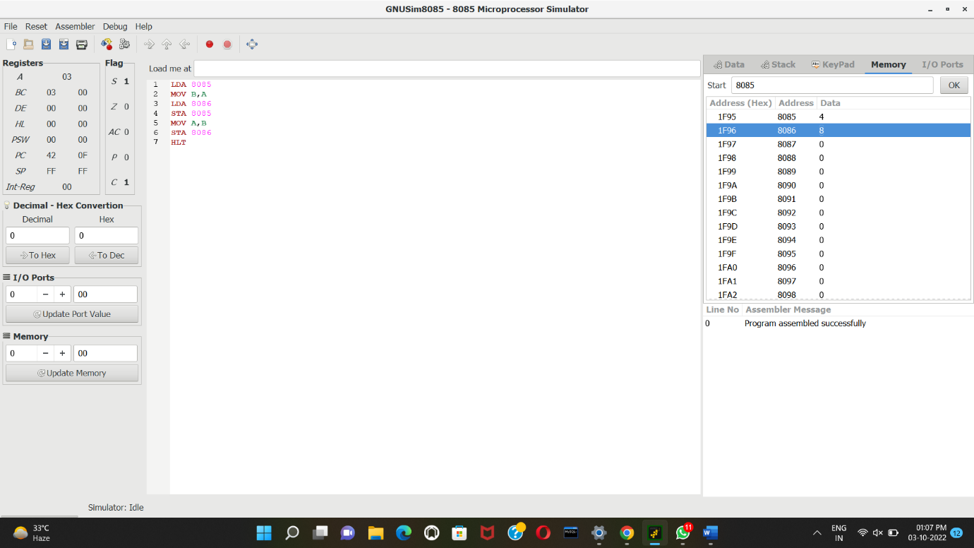

Write a program to convert Decimal number to Hexadecimal number using any high level language.
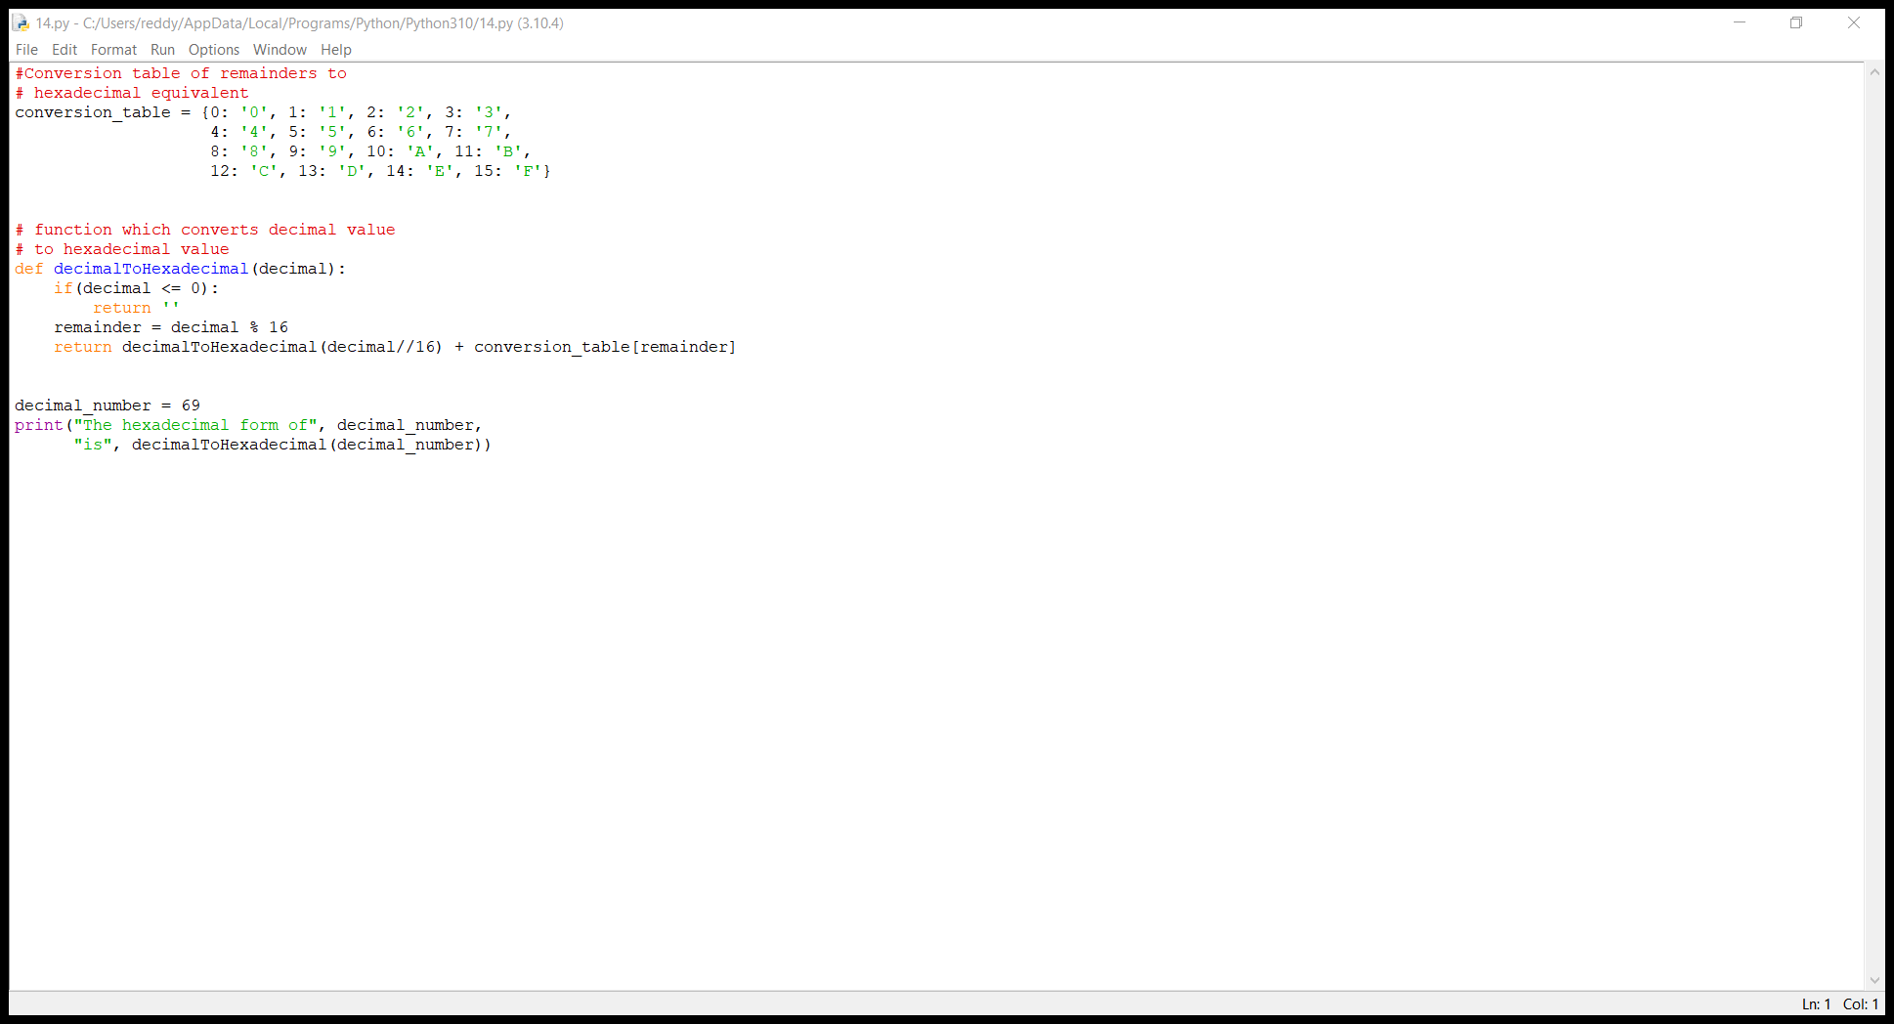
Write a program to convert Binary to Octal number using any high level language

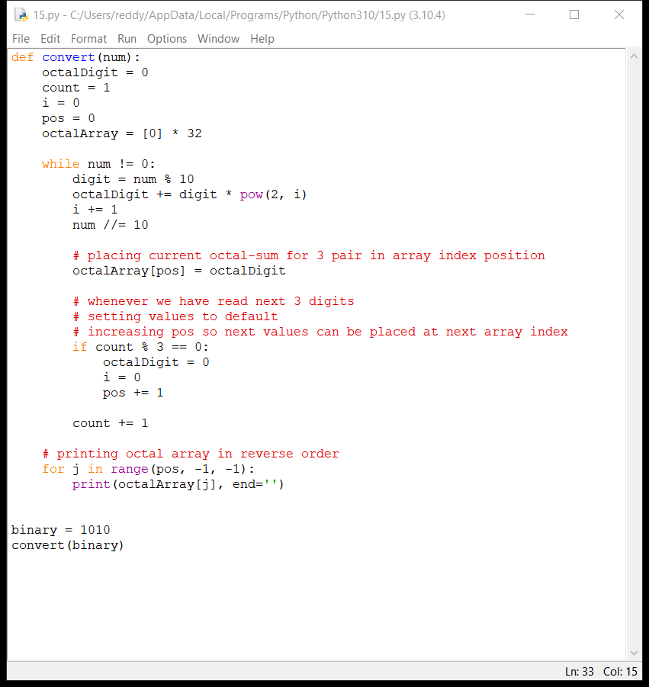
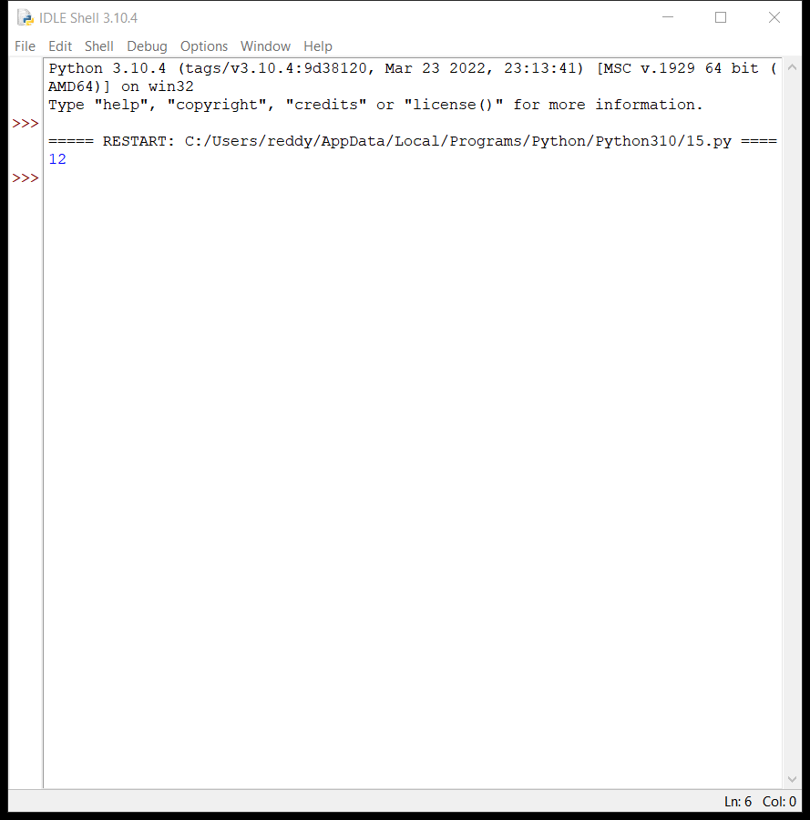
Write a program to convert Binary to Hexadecimal number to number using any high level language.
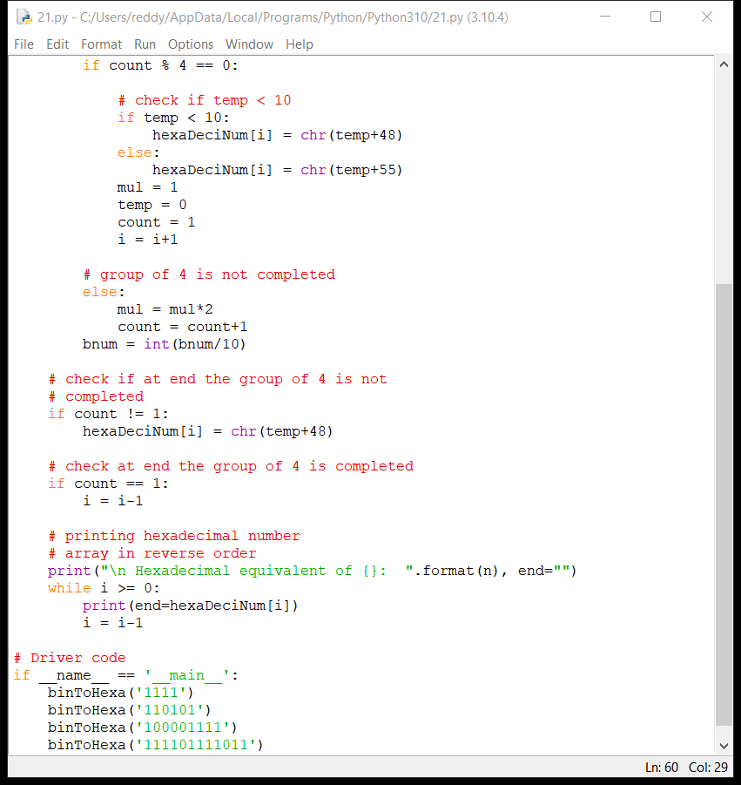
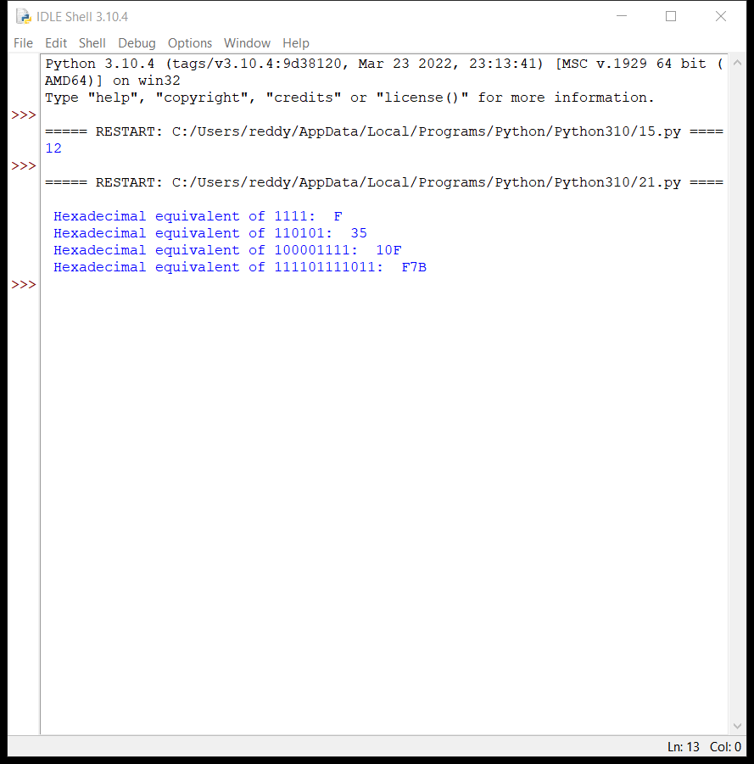
Write an assembly language program for adding two 16-bit data using 8086 processor.
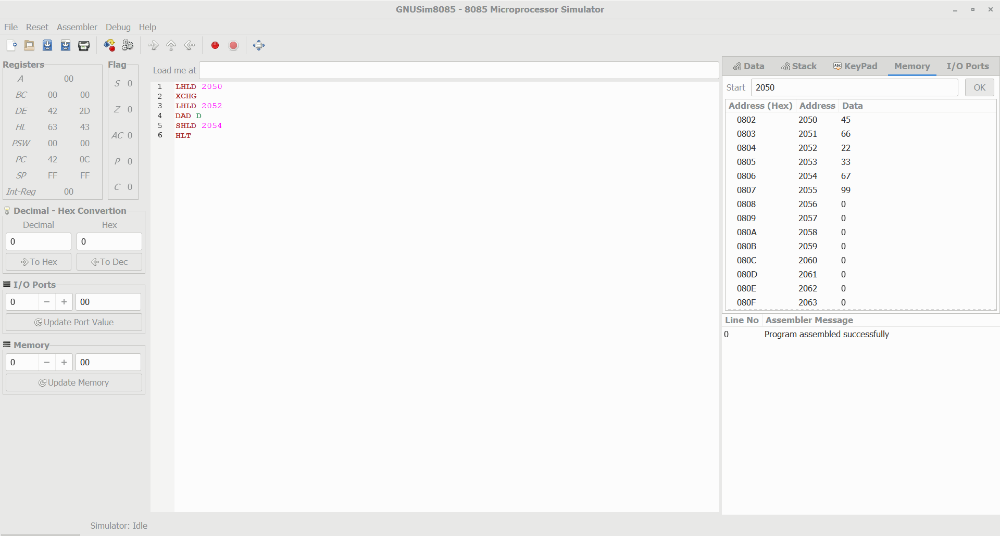
Write an assembly language program for subtracting two 16-bit data using 8086 processor.
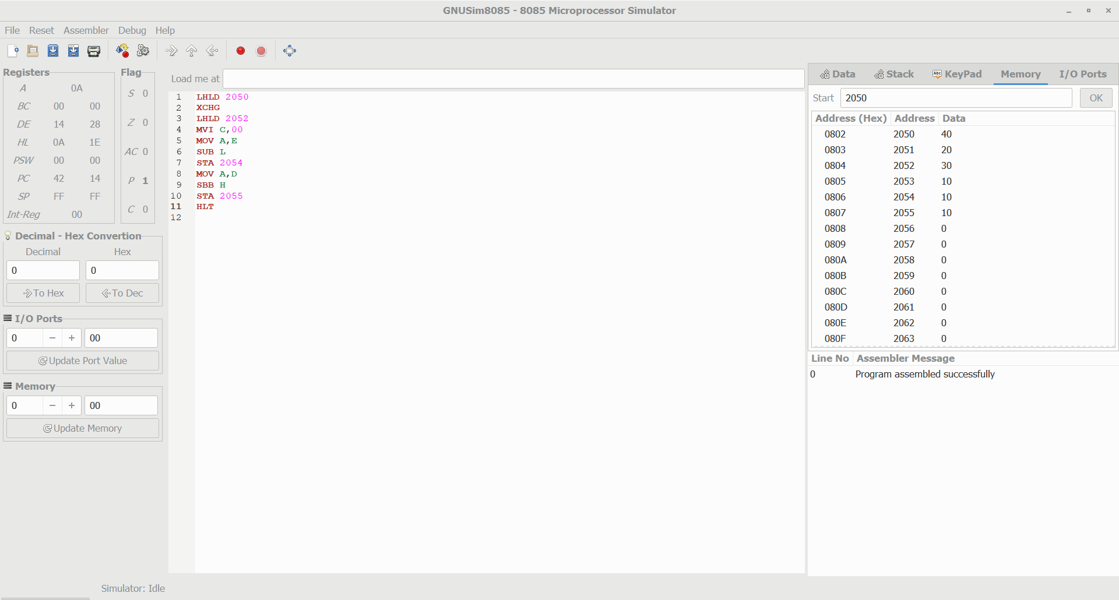
Write an assembly language program for multiplying two 16-bit data using 8086 processor.

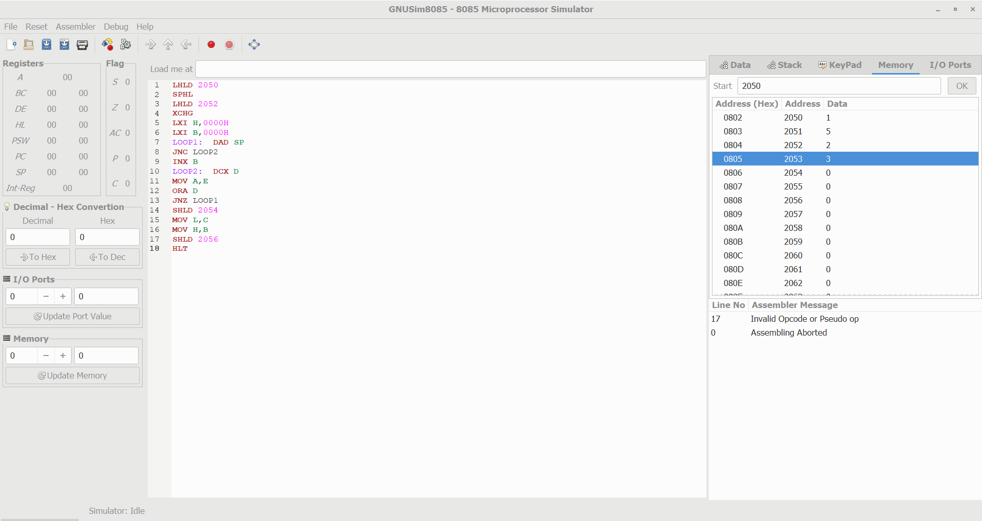
Design and implement 3-bit full adder using logisim simulator
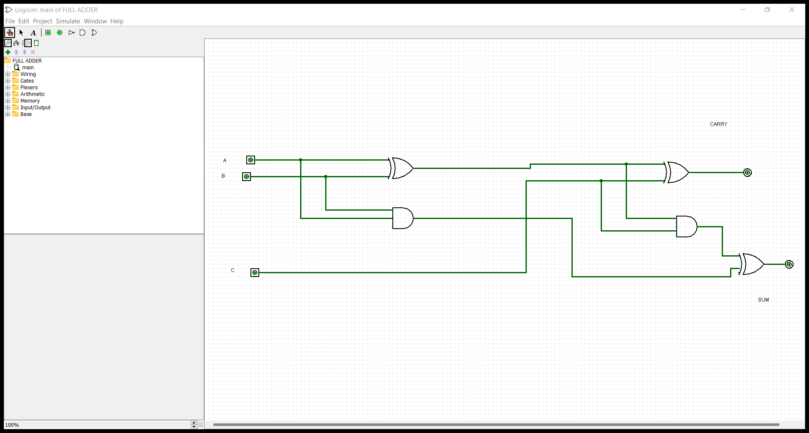
Design and implement 2-bit half adder with NOR gates using logisim simulator.
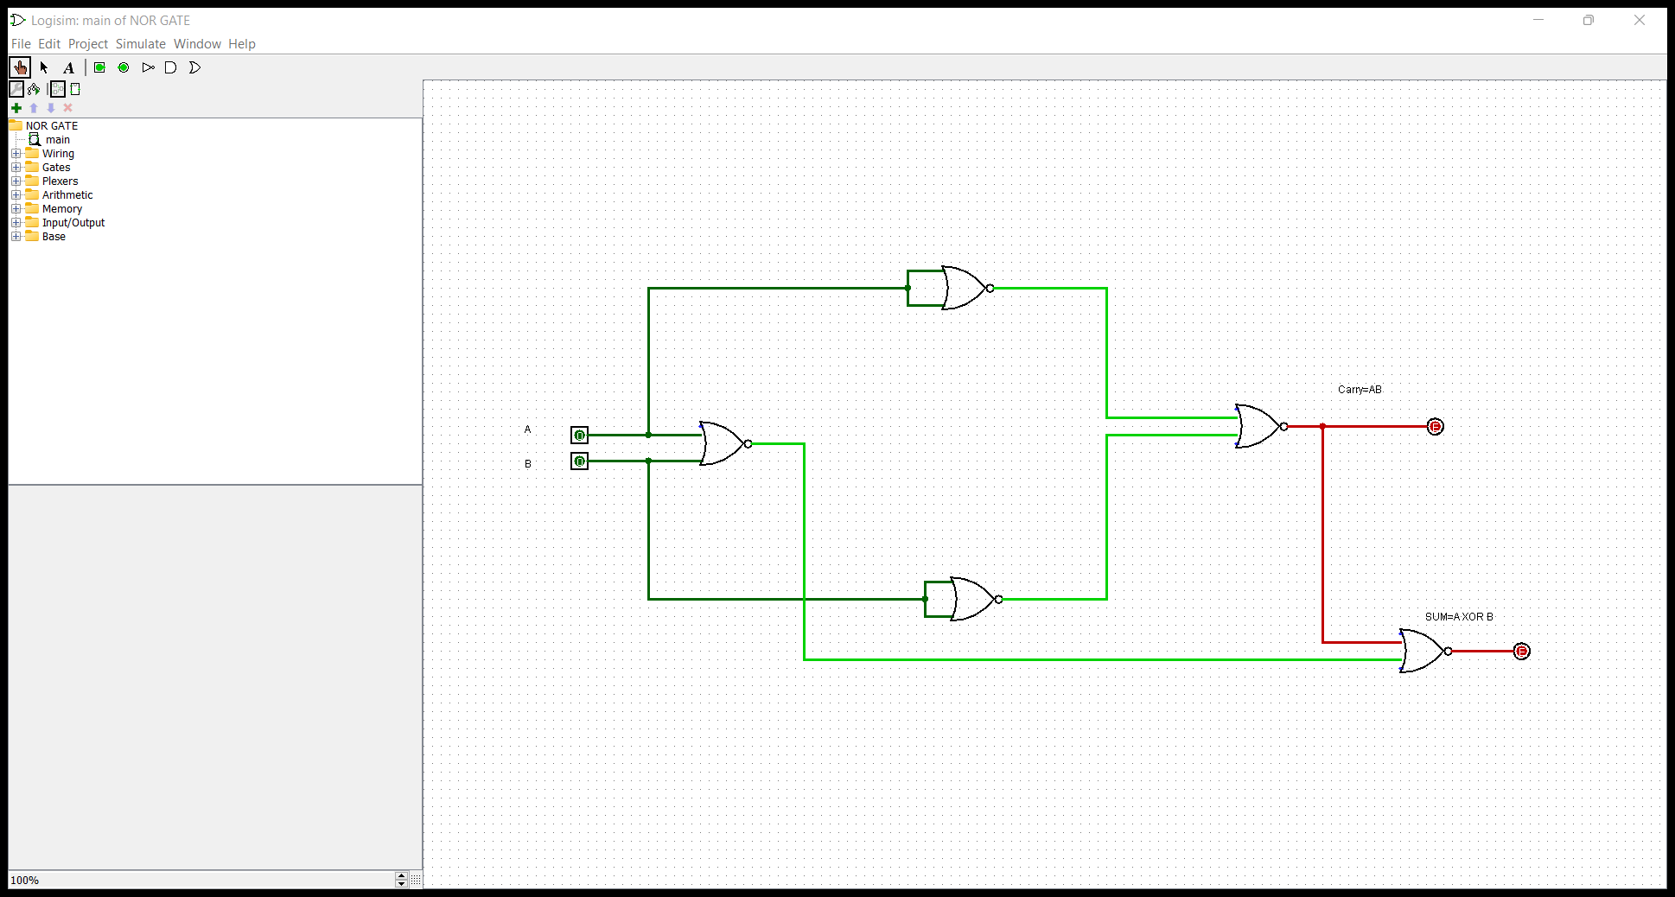

Design and implement 2-bit half adder using logisim simulator.
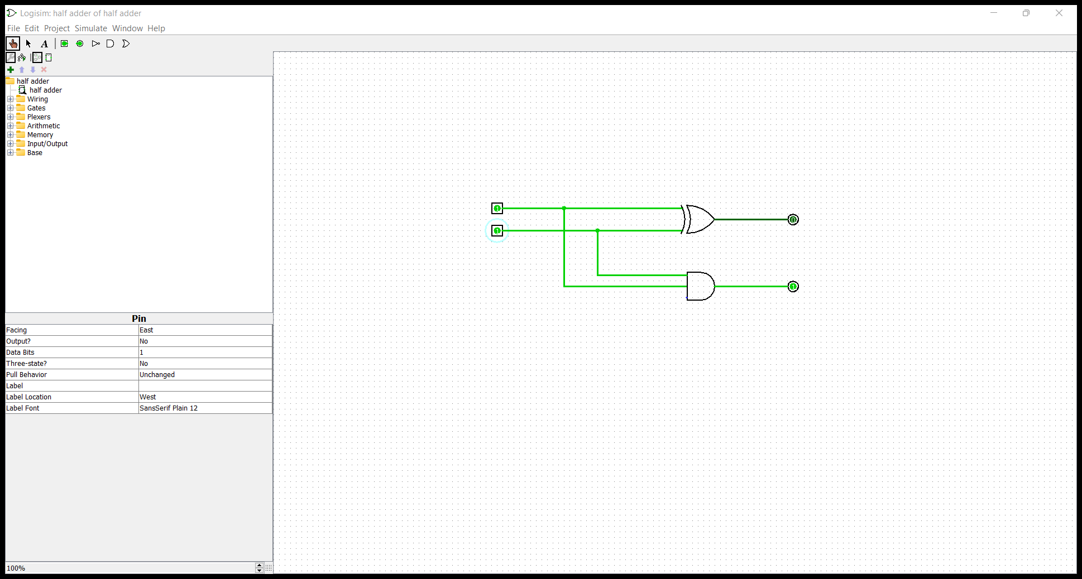
Design and implement 2-bit half adder with NAND gates using logisim simulator.

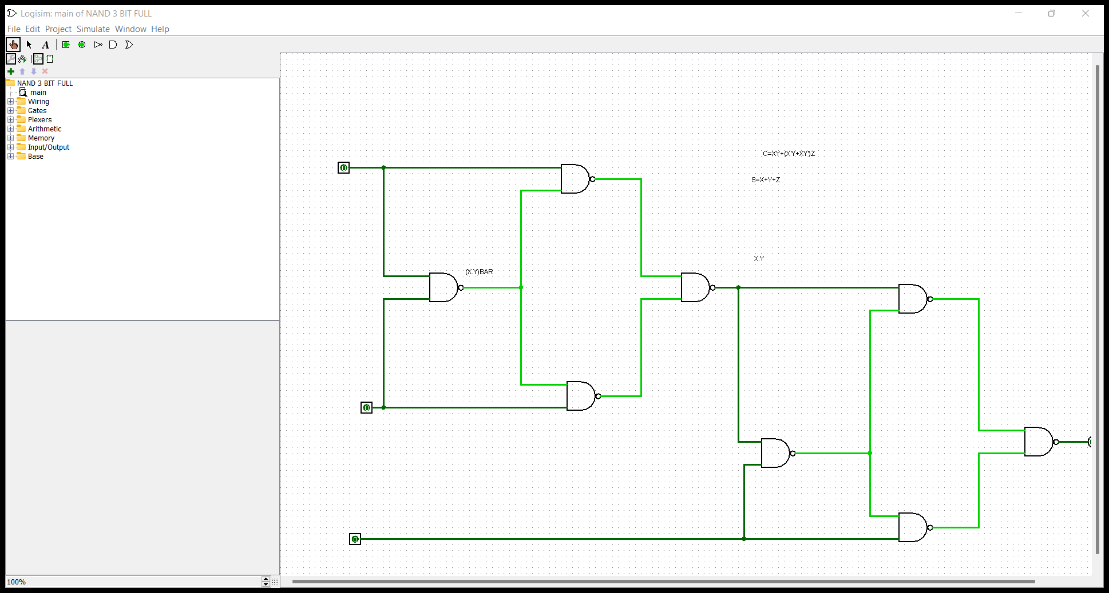
Design and implement 3-bit Full adder with NAND gates using logisim simulator.
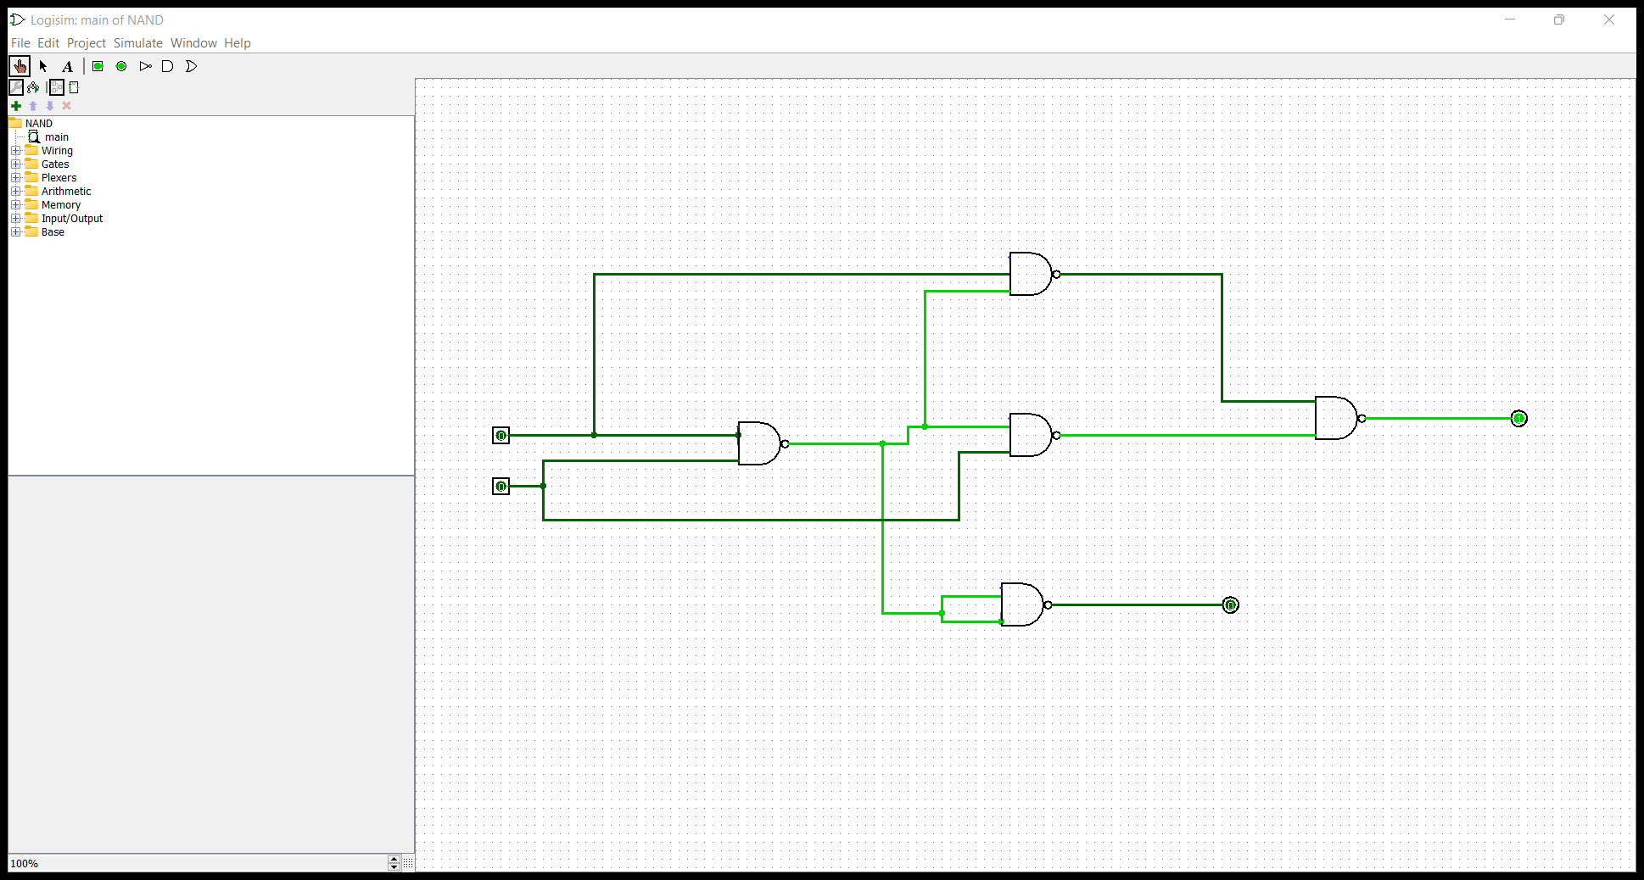
Design and implement 3-bit Full adder with NOR gates using logisim simulator.

Design and implement 4-bit ripple carry adder circuit using logisim simulator.
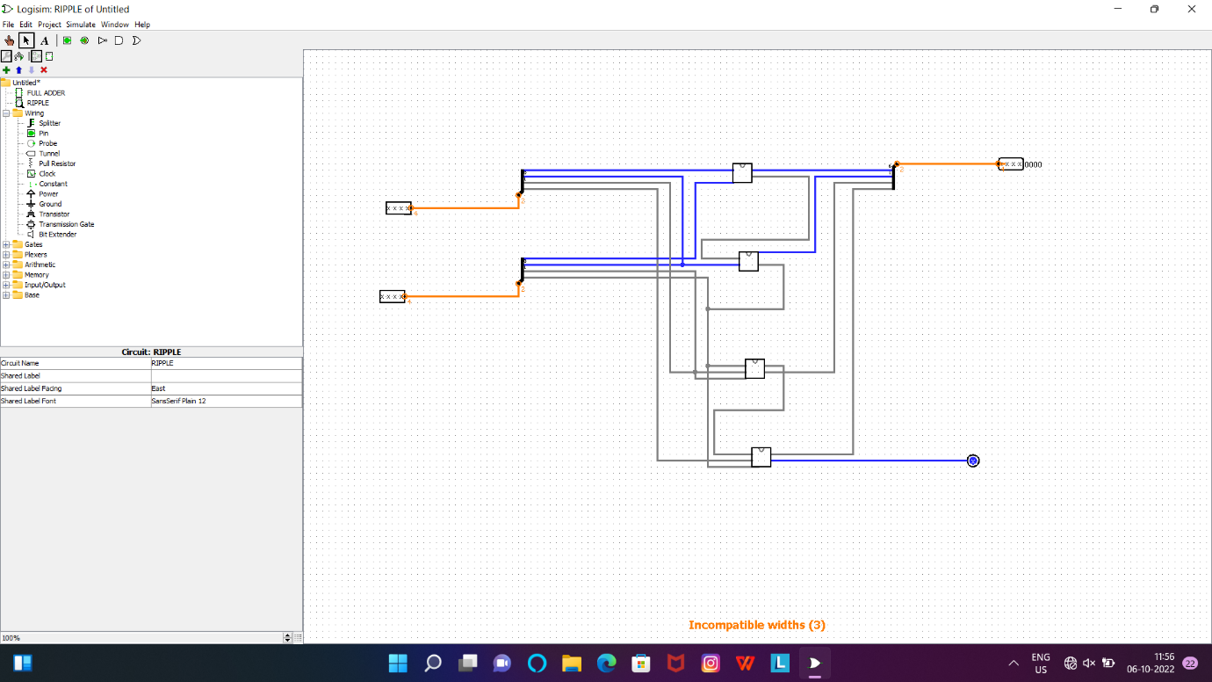
Write an assembly language program for adding two 8-bit data A₇ A₆ A₅ A₄ A₃ A₂ A₁ A₀ and B₇ B₆ B₅ B₄ B₃ B₂ B₁ B₀ using 8085 processor.
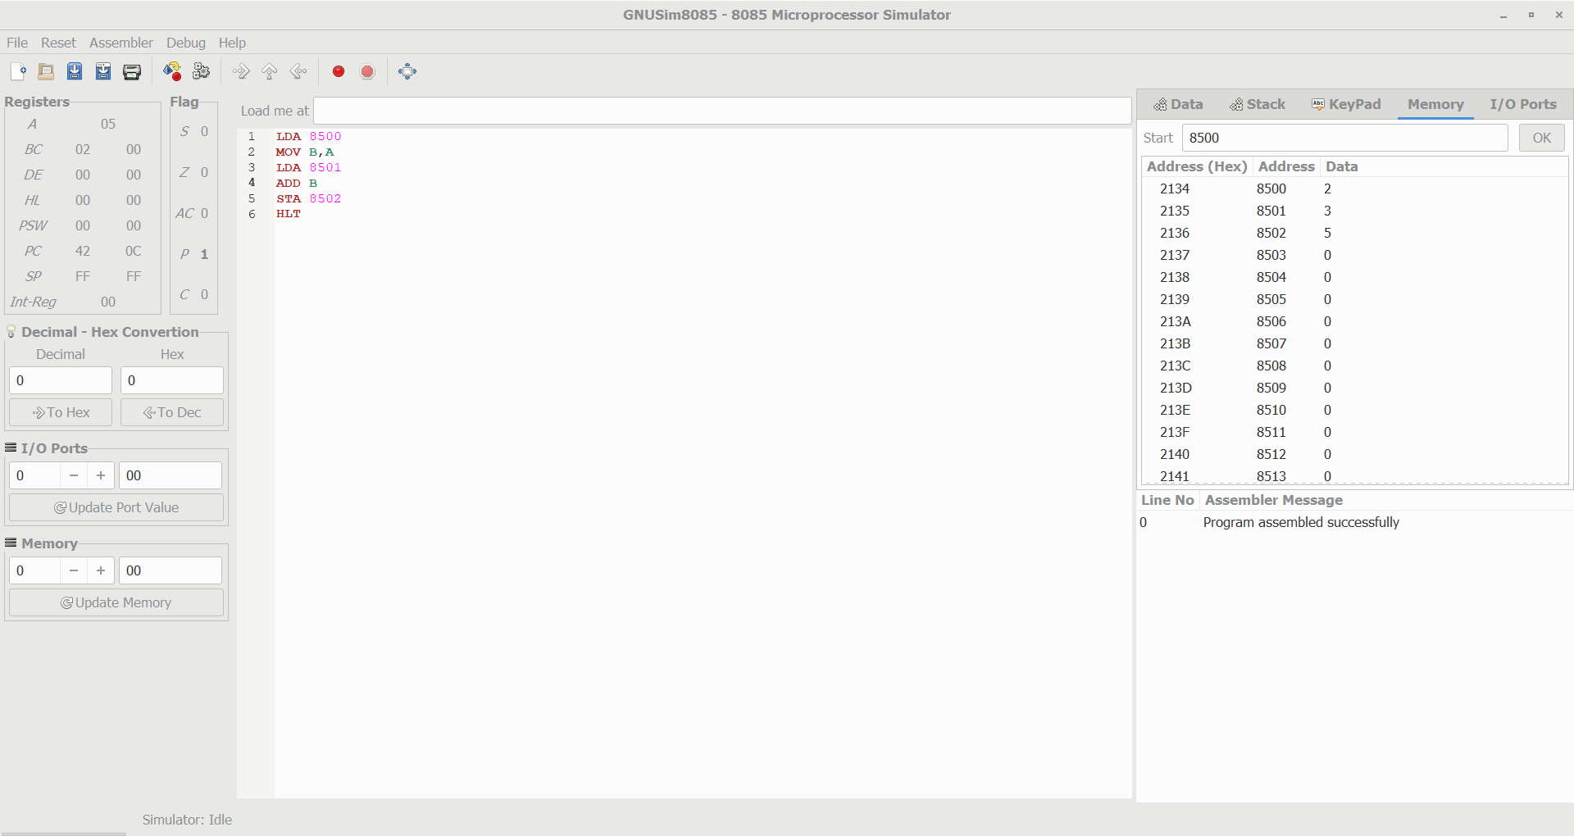
Write an assembly language program for multiplication of two 8-bit data A₇ A₆ A₅ A₄ A₃ A₂ A₁ A₀ and B₇ B₆ B₅ B₄ B₃ B₂ B₁ B₀ using 8085 processor.
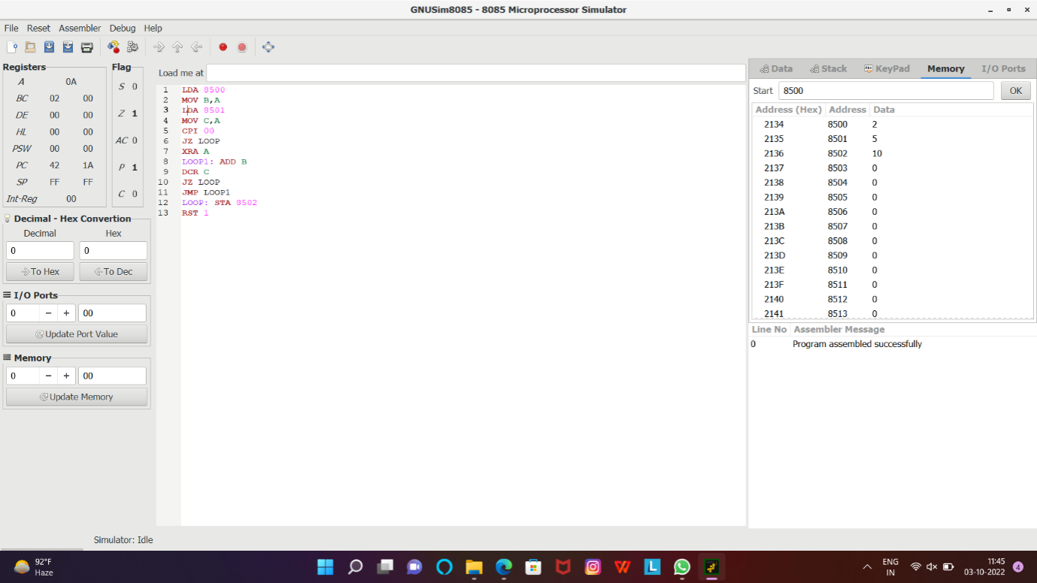
Write an assembly language program for subtraction of two 8-bit data A₇ A₆ A₅ A₄ A₃ A₂ A₁ A₀ and B₇ B₆ B₅ B₄ B₃ B₂ B₁ B₀ using 8085 processor.
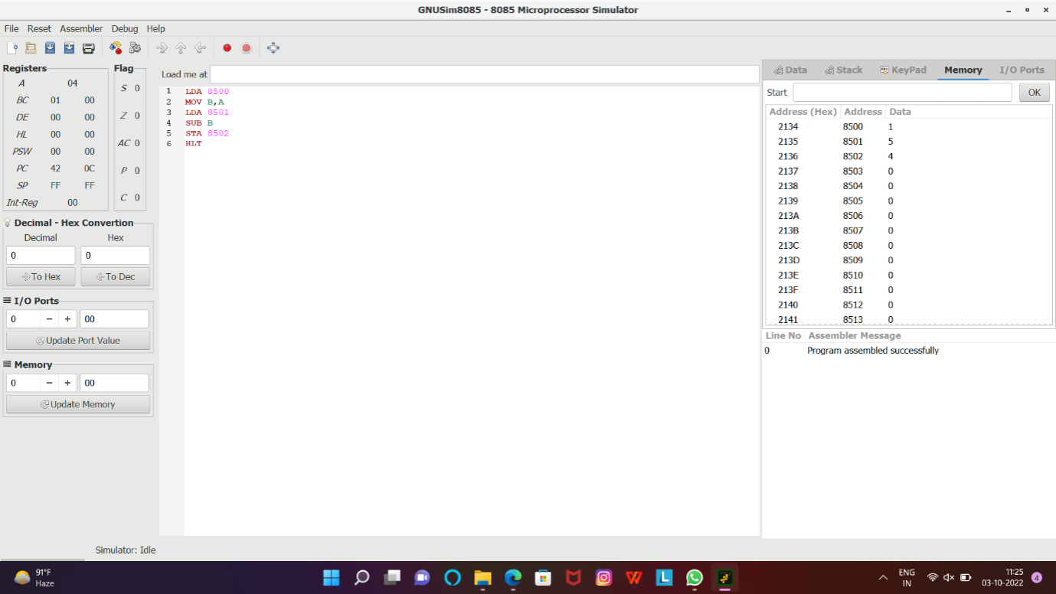
Write an assembly language program to swap two 8-bit data using 8085 processor.
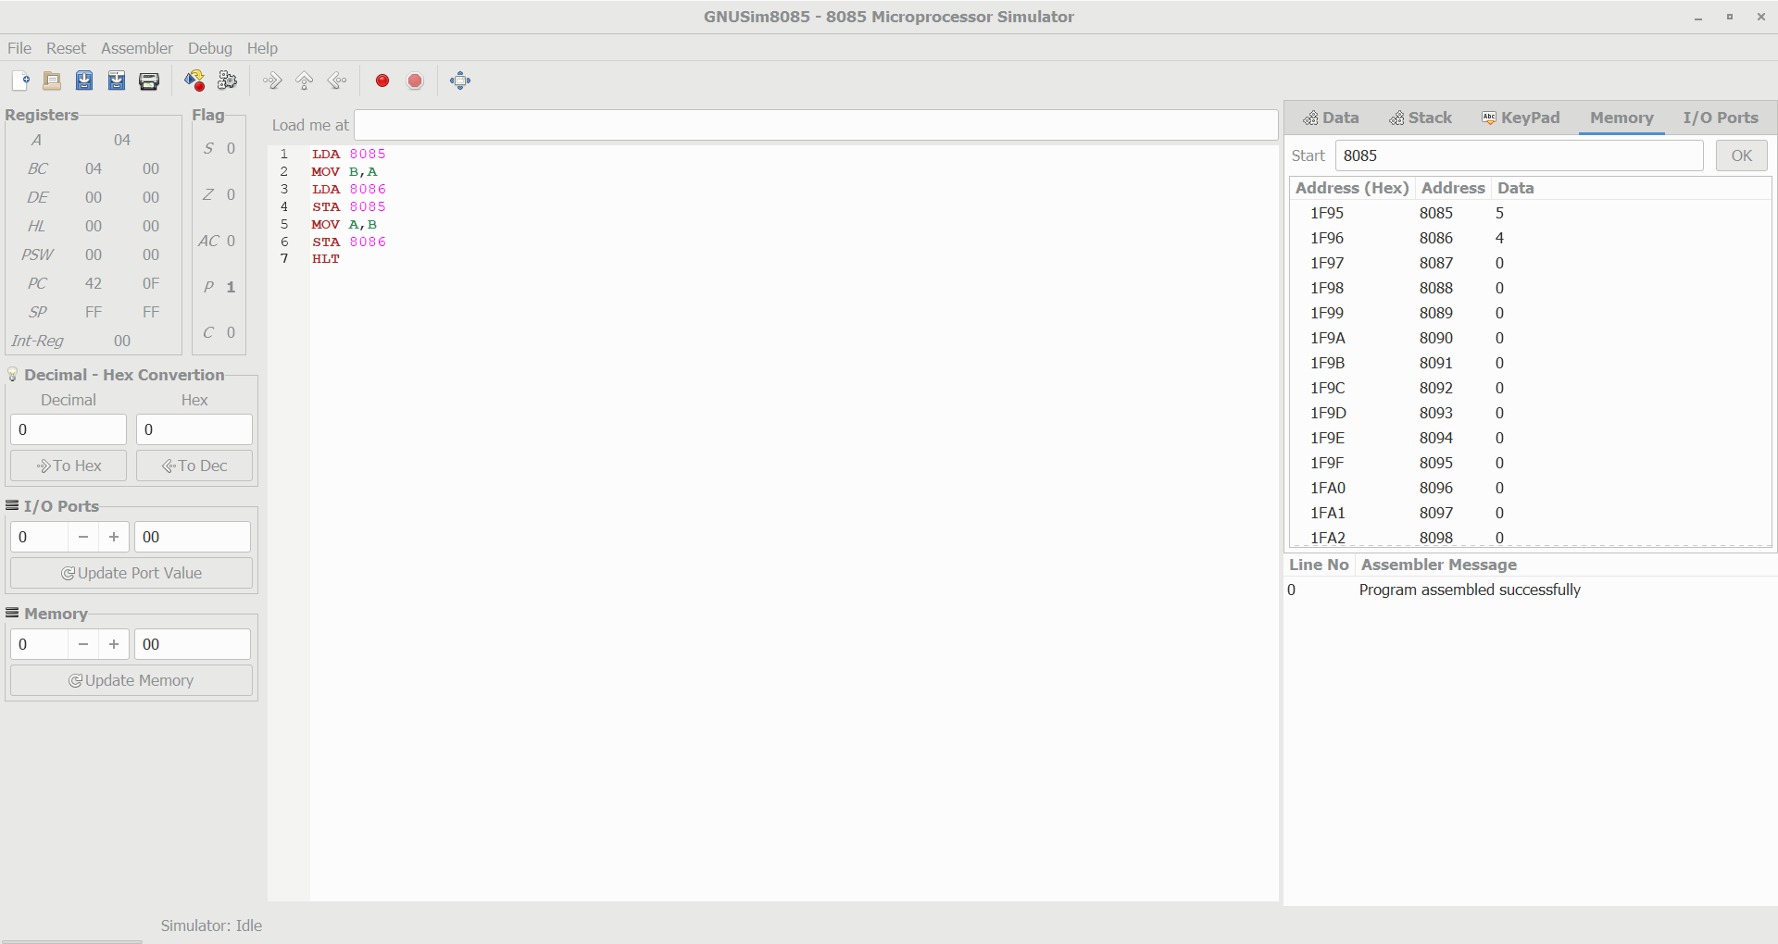
Write an assembly language program to find factorial of n in the given number.
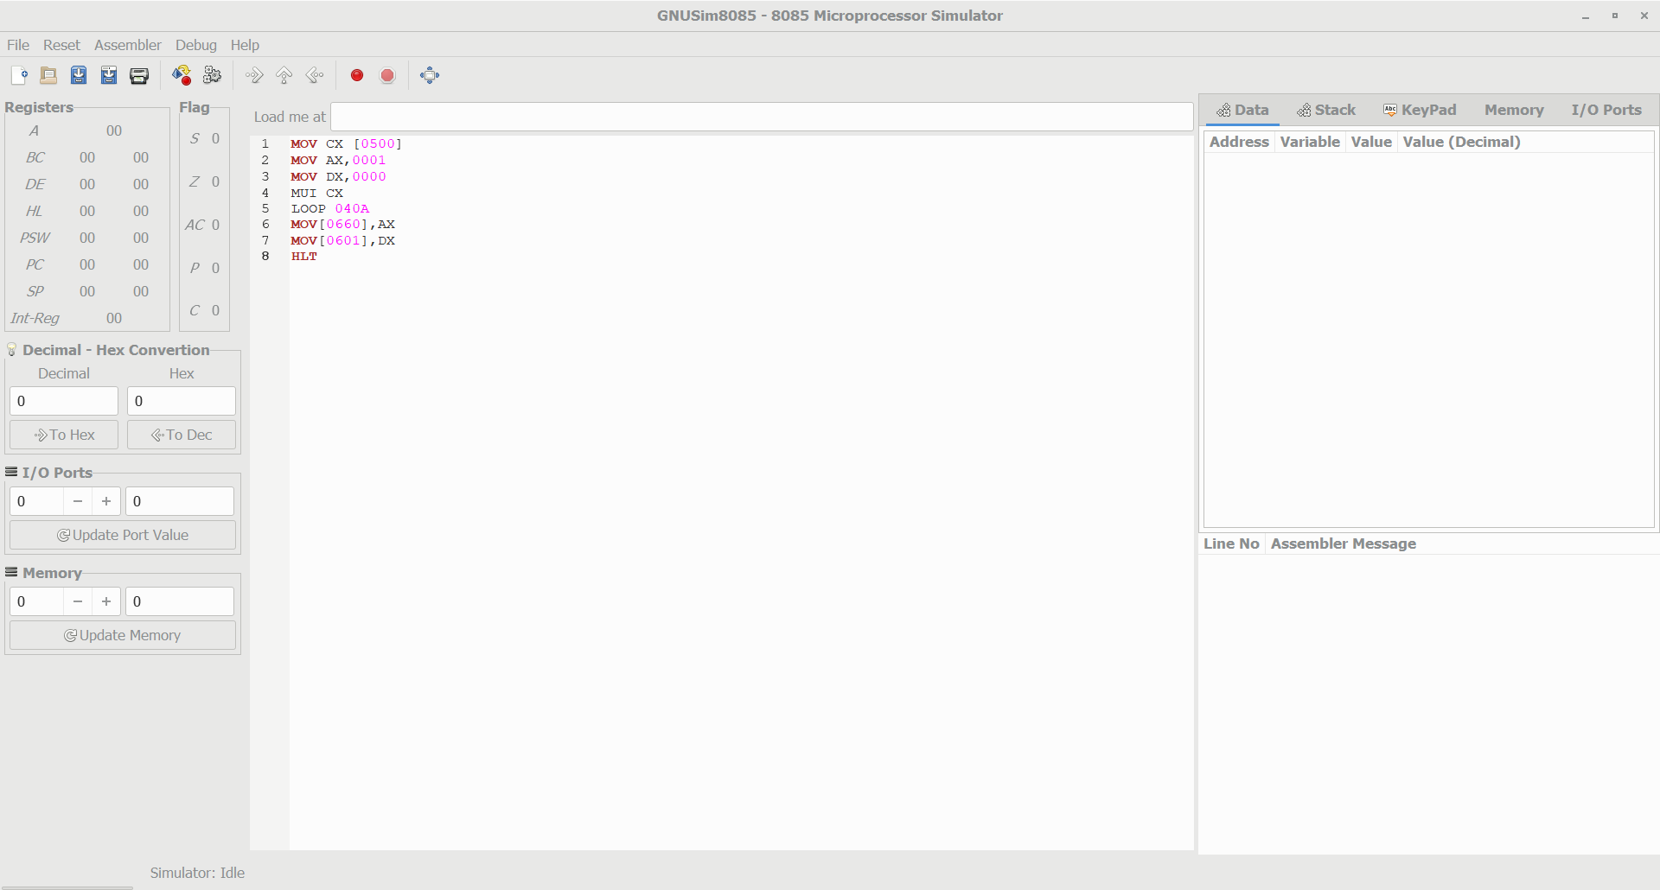
Write an assembly language program to find the given 8-bit number is Prime or not using 8085 processor.
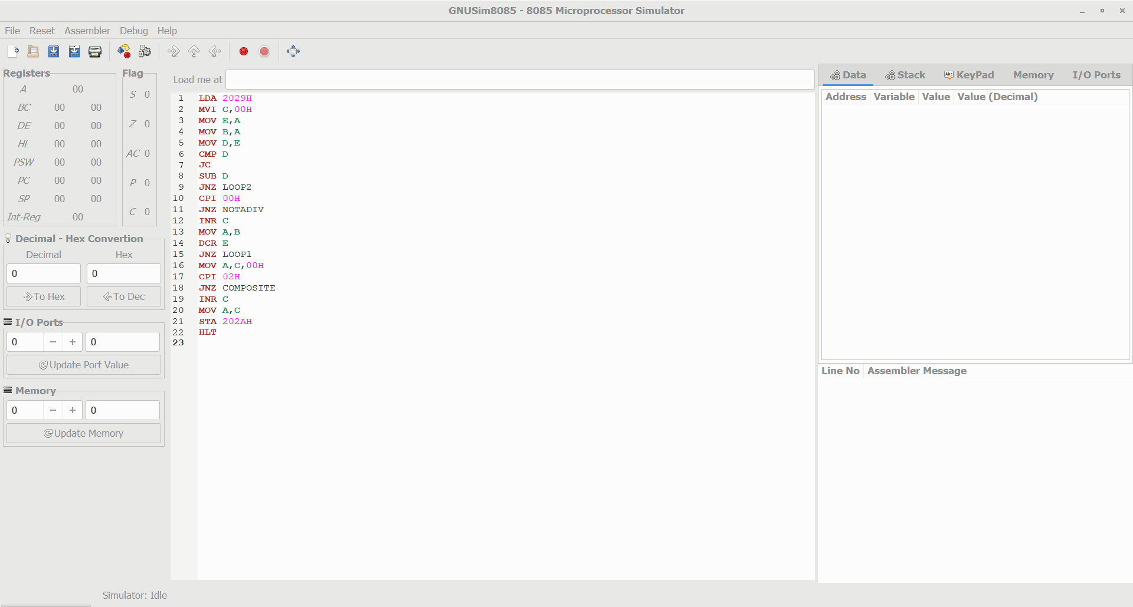
Write an assembly language program for division of two 8-bit data A₇ A₆ A₅ A₄ A₃ A₂ A₁ A₀ and B₇ B₆ B₅ B₄ B₃ B₂ B₁ B₀ using 8085 processor.

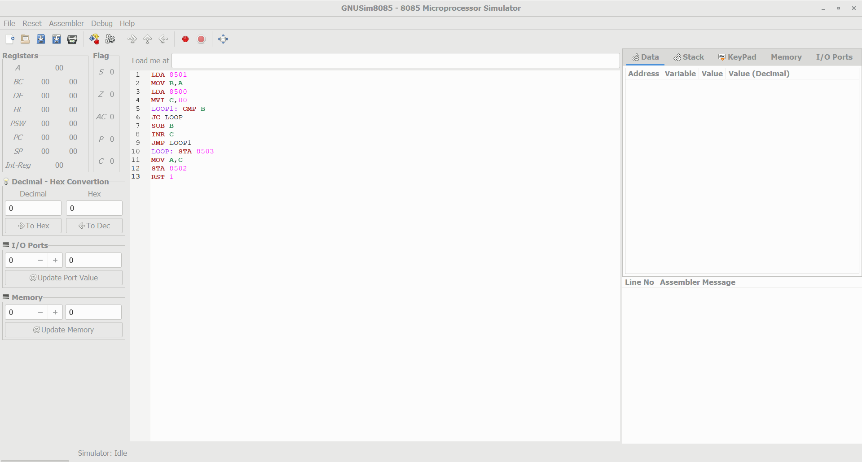
Design of 2 stage pipeline for addition of two numbers using any high level language.

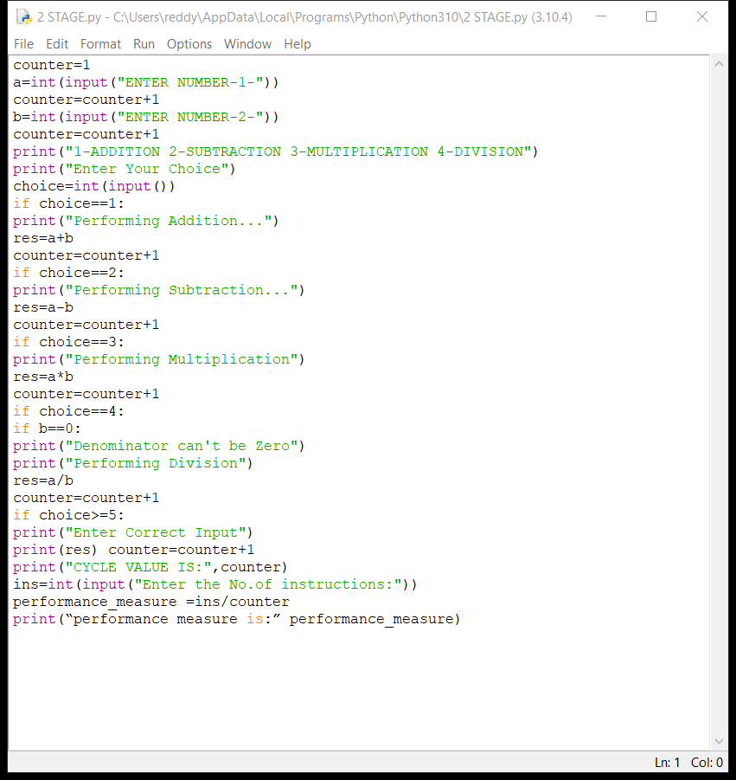
Design of 3 stage pipeline for AND of two numbers using any high level language.

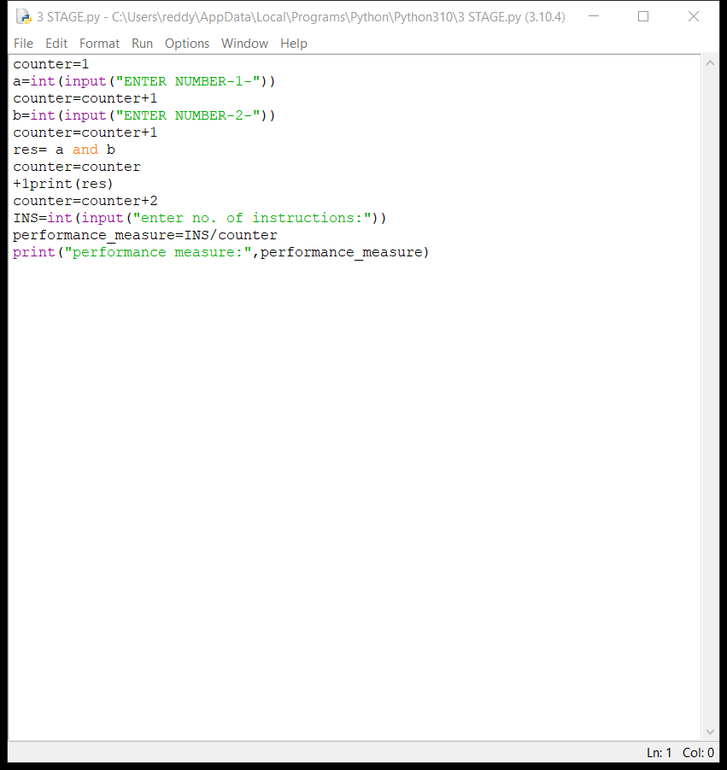
Design of 2 stage pipeline for subtraction of two numbers using any high level language

